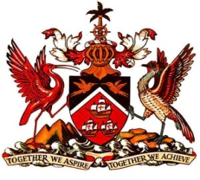
PERMANENT MISSION OF THE REPUBLIC OF TRINIDAD AND TOBAGO
TO THE OFFICE OF THE UNITED NATIONS, GENEVA
Statement by Trinidad and Tobago - Universal Periodic Review of Germany
Palais des Nations, Geneva, 25 April 2013

Mr. President,

Trinidad and Tobago extends a warm welcome to the Delegation of Germany and commends them for the presentation of their National Report.

We note that since its first UPR, Germany has taken a number of steps to strengthen its human rights framework through, inter alia, the introduction of new legislation and signing of international conventions including:

- A law aimed at strengthening the rights of victims of sexual abuse;
- Ratification of the CRPD (Convention on the Rights of Persons with Disabilities) and the Optional Protocol in February 2009;
- Signing of the Council of Europe Convention on preventing and combating violence against women and domestic violence; and,
- Ratification of the Council of Europe Convention on Cybercrime and the related Additional Protocol, intended to help fight acts of a racist and xenophobic nature.

My delegation believes that Germany’s efforts to promote and protect human rights may be further enhanced by its consideration of the following recommendations:

1. Ratification of the International Convention on the Protection of the Rights of All Migrant Workers and Members of Their Families;
2. Continued efforts to address racism, discrimination and xenophobia;
3. Prioritisation of measures to minimise and end, pay differentials between men and women.

I thank you Mr. President.

37-39 RUE DE VERMONT, 1202 GENEVA, SWITZERLAND Tel: 022 918 03 80 Fax: 022 734 91 38 / 022 734 88 26
E-mail: admin@ttperm-misson.ch

